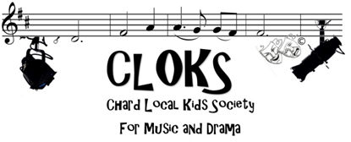
MUSIC REHEARSAL SCHEDULE- THE KING AND I- JULY 2nd- July 4th, 2020
MARCH
Sat 7th- 9.30- 10.30- Anna and Louis (Whistle a Happy Tune)
10.30- 12.30- ALL NEEDED

Sat 14th – 9.30- 10.30- Dialogue scene 1 – Captain, Ann, Louis, Interpreter, Kralahome,
And Guards.
10.30-12.30- ALL NEEDED

Sat 21st – 9.30-10.30- Scene 2- King, Kralahome, Anna, Louis, Lun Tha, Tuptim,
Lady Thiang
10.30- 12.30- ALL NEEDED

Sat 28th – 9.30-10.30- Lun Tha, Tuptim (Kiss in a Shadow)
10.30-12.30- ALL NEEDED

APRIL
Sat 4th – 9.30-10.30- King and Prince- A Puzzlement
10.30- 12.30- ALL NEEDED

****THURSDAY 9th APRIL EASTER WORKSHOP/REHEARSAL- TIMES AND VENUE TBA***

Sat 11th- NO REHEARSAL- EASTER SATURDAY

Sat 18th- 9.30-10.30- Lady Thiang, Thara, Butri and Samorn- Something Wonderful
10.30-12.30- ALL NEEDED

Sat 25th 9.30-10.30- dialogue pages 28-30 and 32-36
10.30-12.30- ALL NEEDED

There will another rehearsal schedule issued at the end of April to take us up to and including the show. We will rehearse every Saturday and also on the following days: Sunday 21st June, Sunday 28th June, Tuesday 30th June and Wednesday 1st July

If you cannot make a rehearsal it is essential that you let me know asap via Facebook, email-fareys@btinternet.com or by phone on 07743 238805 and if you are unsure if you are needed or what time to arrive please feel free to contact me.

Please wear sensible clothes and shoes for rehearsals- no flip flops, crocs or heels.
Don’t forget to bring a snack and drink to all rehearsals.

