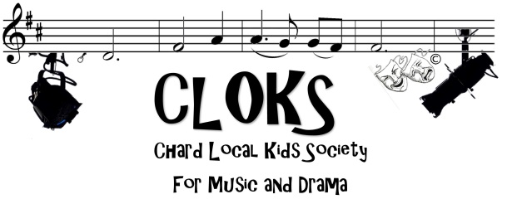
CLOKS NEWSLETTER-JANUARY 2019

Welcome back everyone. I hope you all had a lovely Christmas holiday. A big welcome to all our new members, it’s lovely to see so many new faces and everyone seems to be settling in very well. Rehearsals are going very well indeed! The music is incredibly challenging, but everyone is very engaged and keen to learn, and we are already making great progress. You should all a music schedule and there is also a copy on our website. A new schedule will be out in the next couple of weeks to take us up to the end of April. Go to http://www.cloks.org.uk/rehearsals/ and click on the words ‘Music Rehearsal Schedule’.

TINY TIM’S CHRISTMAS CAROL
Our Christmas show was a huge success and our audiences were enchanted by the story and all the wonderful performances. Combe Church was packed out on both evenings and the atmosphere was warm and festive. The cast all performed brilliantly and as always it was a great team effort. A special well done to all our new and younger members who took it all in their stride and performed with confidence.

EASTER WORKSHOP/REHEARSAL
As usual we will not be rehearsing on Easter Saturday (20th April). Instead of an Easter workshop this year we are planning a visit and journey on the West Somerset Railway from Bishop’s Lydeard to Minehead and back again. We will visit the railway museum and picnic on the beach (weather permitting). The trip will be partially funded by CLOKS and we hope this railway experience will be fun and informative. It fits in very nicely with our show theme this year. Details will be confirmed as soon as possible but the date we have in mind at the moment is Thursday 18 April. We will need definite numbers fairly soon to arrange a group travel discount.

WINE AND CHEESE EVENING- in MAY- Crowshute House- Exact date to be confirmed
We are organising this event for anyone who is currently involved, anyone wishing to be more involved and anyone who would like to know more about what we do. This social evening will be TOTALLY FREE! And we’d love to see lots of you there. We will have someone there to answer any questions or talk to you about every aspect of CLOKS from technical to costumes, chaperoning, stage management and production. Please don’t worry no one will pressure you or badger you to help more it is simply a chance for everyone to get to know each other and if by any chance any of you would like to do more then it is a chance for you to let us know. There will be plenty of cheese and plenty of wine so please come and join us.

NO PHONE POLICY
Please note that phones will be collected at the start of rehearsals and returned at the end. This is for safety, especially once we start floor rehearsals. If your child needs to make an emergency call, then of course they may do this. Please try and remember to collect your phone at the end of the rehearsal.

THE RAILWAY CHILDREN- Thursday 4th- Saturday 6th July 2019
Please note that our show is a week later than usual, this is so we can avoid a clash with the Holyrood year 11 school prom. As well as the actual show dates and our usual Saturdays there will be some week day evenings in the run up (probably on a Thursday), two Sundays 23rd and 30th June and two dress rehearsals on Tuesday 2nd and Wednesday 3rd July. (Monday 1st July is a cast night off) Please note that we will be doing a matinee on the Saturday.
As previously mentioned a new schedule will be out at the start of March. This will take us up to the end of April. We will then issue a final schedule up to and including the show.

CLOKS BLACK LOGO T. SHIRTS
All members need to have the black t-shirt with the new CLOKS logo on it (Similar to the logo at the of this page) If you have not already purchased one please see Jo (one of our costume ladies) and she will help and advise. You will all need one by the Easter trip and for promotional photos nearer the show.

FACEBOOK/ WEBSITE
A lot of our communication is via Facebook, but I am aware that a few people do not have access to or choose not to have Facebook. With this in mind we will continue to hand out hard copies of schedules, newsletters and flyers. We will also put copies on our CLOKS website www.cloks.org.uk

Please feel free to contact me on 01460234335, Facebook, email-fareys@btinternet.com or mobile 07743238805 if you have any questions or concerns. Please continue with communication regarding attendance at rehearsals and never be afraid to ask if you are needed on a certain date.

Thanks for all your continued support
Kind regards
Maria and the CLOKS team.

